1. The size of the pulse decreases because it loses energy through transfer of energy.
2. The original pulse is reflected on the opposite side of the spring from the original pulse.
3. As the tension of the spring increases, the pulse speed increases as well.
4. The size of the pulse increases from the spring to the slinky. The speed of the pulse increases from the spring to the slinky and the direction of the pulse stays the same from the spring to the slinky.
5. The speed and the size of the two pulses decrease, the direction and shape of the two pulses flips.
6. The two pulses don’t flip. The point on the spring that does not move at all is in the middle or where the two pulses meet.
7. The displacement of the pulses either cancels each other out or adds to each other making a bigger wave.
8. The faster the velocity, the increased frequency which decreases the amount of wavelength.

**Longitudinal** is when a wave is extending in the same direction of the length of another wave. An example would be when you send a wave through a spring then send another wave in the same direction as the previous spring.

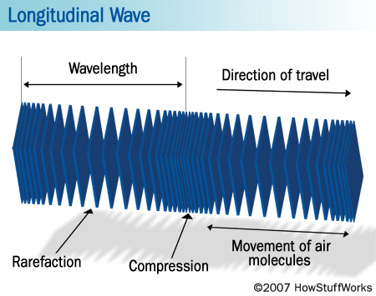

**Transverse** is when a wave is lying or extending across or in a cross direction of another wave. An example of this would be when you hit a spring one way causing what seems to be a bigger wave. A **wavelength** is when the distance, measured in the direction of propagation of a [wave](http://dictionary.reference.com/browse/wave), between two successive points in the [wave](http://dictionary.reference.com/browse/wave) that is characterized by the same phase of oscillation. An example of this is the distance between two points of the wave being up or down. **Amplitude** is the [absolute value](http://dictionary.reference.com/browse/absolute+value) of the maximum displacement from a zero value during one period of an oscillation. An example of this is measuring the height of the wave. A **trough** is the trench between two high/low points and an example of this would be the gap between the Grand Canyon. The **crest** is the ridges on the outside of the trough and an example of this is the land on either side of the Grand Canyon.

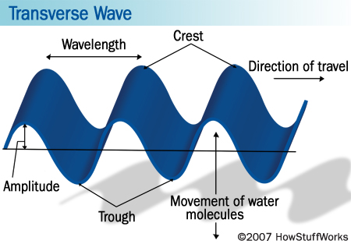

**Refraction** is the change of direction of a wave in passing obliquely from one medium into another in [which](http://dictionary.reference.com/browse/which) its wave velocity is different. An example of this would be shining light off of a mirror.

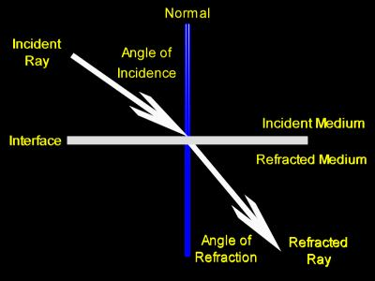

**Interference** is the process in [which](http://dictionary.reference.com/browse/which) two or more [waves](http://dictionary.reference.com/browse/electromagnetic+waves) of the same frequency combine to reinforce or cancel each other, the amplitude of the resulting wave being equal to the sum of the amplitudes of the combining waves. An example of this would be when you hit a spring one way, then hit it the other way causing the wave to cross out and be in the middle. **Constructive interference** is the interference of two or more waves of equal frequency and phase, resulting in their mutual reinforcement and producing single amplitude equal to the sum of the amplitudes of the individual waves. An example of this would be hitting a spring the same way twice and when the two waves meet it seems that there is a single big wave. **Destructive interference** is the interference of two waves of equal frequency and opposite phase, resulting in their cancellation where the negative displacement of one always coincides with the positive displacement of the other. An example of this is when you hit a spring one way, then hit it the other way causing the wave to cross out and be in the middle. **Periodic wave** is a fluent and consistent wave and an example would be a sine or cosine graph which is in the diagram below. **Frequency** is the number of cycles or completed alternations per unit time of a wave or oscillation. An example of this is one cycle of a cosine graph which is in the diagram below.

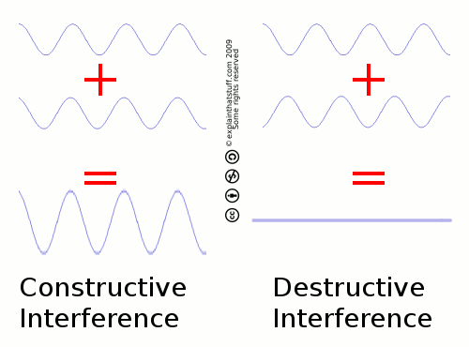

**Transmission** is the broadcasting of a wave from one thing to another and an example of this would be the wave between a spring and a slinky. **Reflection** is the act of reflecting or the state of being reflected so in the slinky example the wave is not reflected as well from the slinky to the wave.

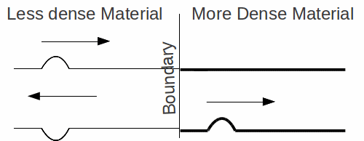

**Standing waves** are a wave in a medium in [which](http://dictionary.reference.com/browse/which) each point on the axis of the wave has associated constant amplitude an example of this would be an ocean wave.

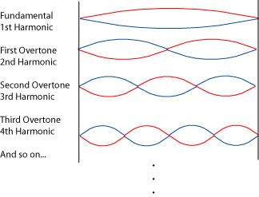

Works Cited

Harris, William. "How the Doppler Effect Works." *HowStuffWorks*. Web. 04 Mar. 2012. <http://science.howstuffworks.com/science-vs-myth/everyday-myths/doppler-effect1.htm>.

"IB Physics Notes - Waves and Oscillations - Reflection and Transmission of Waves at the Boundary Between Two Media." *IB Physics Notes*. Web. 04 Mar. 2012. <http://www.astarmathsandphysics.com/ib_physics_notes/waves_and_oscillations/ib_physics_notes_reflection_and_transmission_of_waves_at_boundary_between_two_media.html>.

"Ray Optics, Light Refraction." *Light Refraction*. Web. 04 Mar. 2012. <http://zonalandeducation.com/mstm/physics/light/rayOptics/refraction/refraction1.html>.

Schmidt-Jones, Catherine. "Standing Waves and Musical Instruments." *Connexions*. Web. 04 Mar. 2012. <http://cnx.org/content/m12413/latest/>.

Woodford, Chris. "Thin-film Interference." *How Anti-reflective Coatings, Thin-film Interference, and Iridescence Work*. 31 Mar. 2011. Web. 04 Mar. 2012. <http://www.explainthatstuff.com/thin-film-interference.html>.